# Web 3 Practical – JavaScript Events

1. Using HTML in line event handling, connect the p element in file p1.html to a function in p1.js that calls an alert function when the paragraph is clicked.
2. Repeat exercise number 1, but this time using an object property event handler
3. Repeat exercise number 1, but this time using the listener approach event handler
4. Repeat exercise number 3, without touching the HTML (the script element should stay within the head element). Hint: use the onload event.
5. Using the listener approach event handler, write the necessary JavaScript for paragraphs to adopt the CSS class .underline upon mouseover events and remove that class upon mouseout events. Upon click events, the application should show an alert box displaying the mouse coordinates on the screen where the click event occurred.

(you can use html ids for the p elements in the html)

1. D:\Dropbox\Work\Teaching\IN712 - Web Programming 3\difficultyIcon.pngWhile images are an important part of web pages, in some situations you might not want display all the images on a page. For example, if your user is accessing the page from a phone with a slow internet connection, or if your user is running a TTS (text to speech) converter, it is better to display a text alternative. In this exercise you will build a page that allows the user to toggle between displaying an image and displaying just the file name. An example is shown below:

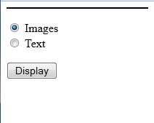 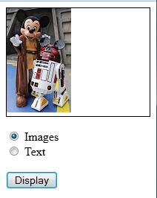 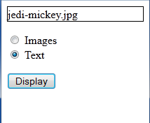

Page Open On Click – Images Selected On Click – Text Selected

make sure to use the window.onload event and bind it to a function that provides and entry point to your script.

1. Use the video HTML element to include the provided video video.mp4 in an HTML page. Include controls on the video, preload the video upon page loading and use the provided poster image videoPoster.jpg
2. Expand the functionality of exercise p7 with 3 buttons to programmatically play, pause and mute the video. The mute button should toggle its inner HTML with the text Mute/Unmute and should provide the corresponding functionality. Your script should respond to the pause event on the video object with an alert box informing the user “you have paused the video at time x.xx seconds”